Type or paste the title of your article here (use style: article title)
Name and surnameª*, Name and surname^{b}, Name and surname^{c} (use style: author names)
ªUniversity, Faculty, Department, City, State or
^{b}Institution, department or sector, City, State or
^{c}The company, department or sector, City, State (use style: afilation)
*Corresponding author: author@mail.rs (use style: contact details)

INTRODUCTION (use style: chapter)
First paragraph: use style: paragraph for the first paragraph within a chapter or subsection.
The following paragraph: use style: next paragraph for each of the following paragraphs within a chapter or subsection.

MATERIAL and METHOD (use style: chapter)
First paragraph: use style: paragraph for the first paragraph within a chapter or subsection.
The following paragraph: use style: next paragraph for each of the following paragraphs within a chapter or subsection.

Subsections: use style: subsections for possible subsections within the chapter

RESULTS and DISCUSSION (use style: chapter)
First paragraph: use style: paragraph for the first paragraph within a chapter or subsection.
The following paragraph: use style: next paragraph for each of the following paragraphs within a chapter or subsection.
- Numbering (use style: numbering)

Equations / Formulas (use style: equations/formulas) ( )

CONCLUSIONS (use style: chapter)
First paragraph: use style: paragraph for the first paragraph within a chapter or subsection.
The following paragraph: use style: next paragraph for each of the following paragraphs within a chapter or subsection.

Literature (use style: chapter)
Use style: literature to refer to the literature used in the work. See the manual for more detailed instructions on citation style.

Acknowledgment (use style: chapter)
Use style: paragraph for acknowledgment. Insert acknowledgment if needed.

Table 1
Table title (Use style: table title)
1
2
3
Use style: text in the table for everything in the table. Insert tables at the appropriate place in the text.

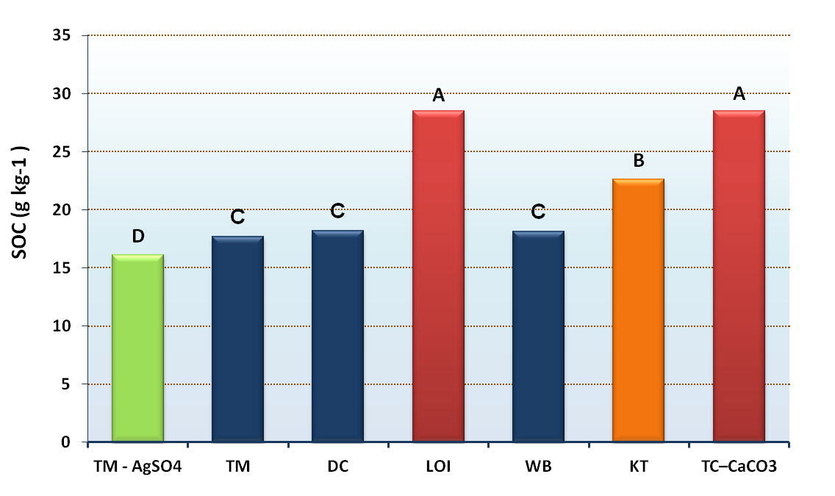

Figure 1. Use style: image or chart for title of the same. Get a license and include the recognition required by the copyright owner if the image is played from another source. Center the image. Insert images or charts at the appropriate place in the text.

